Practical 6
Sneha Yadav
1(a)
- Enter letters instead of numbers
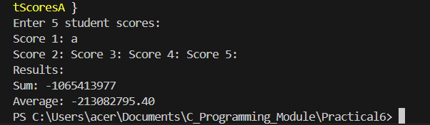

Ends scan immediately and take garbage values and give solution.

- Enter scores outside the valid range (0-100)
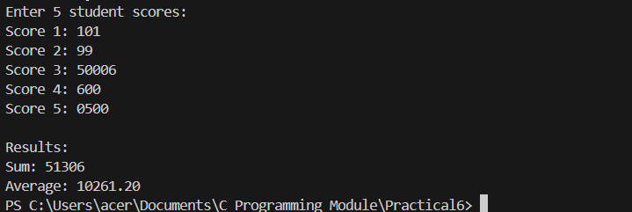

Takes invalid inputs without validating the range.

- What if we wanted to process 100 students instead of 5?
int scores[100];
for(int i=0; i<100; i++){
printf("Score %d: ", i + 1);
scanf("%d", &scores[i]);
}
for(int i=0; i<100; i++){
sum+=scores[i];
}
average=(double)sum/100;
1(c)
- Why do we start the loops at `i = 1` instead of `i = 0` when finding max/min?
As we have, int maxScore=scores[0]; int minScore=scores[0]; where, score is an array and its 0 index is initialized to both max and min score. So, when comparing max and min scores, the initial value(0 index) is compared with other index values. The loop starts at i=1 instead of i=0 to avoid wasting cycle where index 0 is compared to itself.

- What would happen if all students got the same score?
If the maxScore and minScore are initialized before scanning, it takes garbage value of score[0]. This results in error in calculation. When initializing after scanning, the highest and lowest score remains the same and there is no error. So, if every student got the same score, the outputs remain proper.

- What vulnerabilities exist in this program?
- It does not check if scores are within a valid range like 0 to 100.
- It accepts letters or symbols instead of numbers without showing an error.
- It does not check if the input was successfully read into the variable.
- The total sum can become too large to store correctly if numbers are huge.

2(b)
- What happens if multiple students have the same score?4
If multiple students have the same score, the statistics remain unhindered but the search will point the position of the 1st same value rather than every same values.
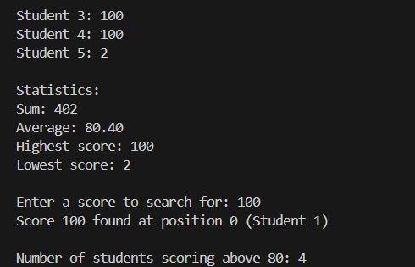

- How could you modify linearSearch to find all occurrences?
int found[] as an array that stores the found index of same number
int linearSearch(int scores[], int size, int target, int found[]){
int count=0;
for(int i=0; i<size; i++){
if(scores[i]==target){
found[count]=i;
count++;
}
}
return count;
}
- What security vulnerabilities still exist in this program?
- scanf return value not checked, allowing invalid input.
- No validation to ensure scores are within a valid range (0-100).
- The total sum can become too large to store correctly if numbers are huge.
- Uninitialized memory used if input reading fails.
3(a)
Question 1: Array Bounds Vulnerabilities
In your current programs, what happens if:
-A loop uses `i <= size` instead of `i < size`?
Since scores[] is an array holding only 5 numbers of students as defined to NUM_STUDENTS, it cannot take greater index. It only takes indices from 0 to 4.
It depends on which loop uses the i<=size instead of i<size. There will be garbage value and error calculation if used in calculation loop.
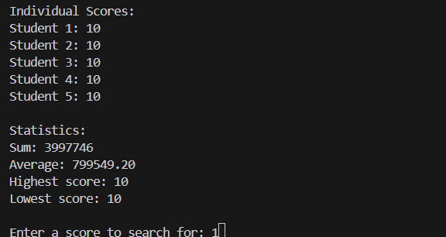

If used in scanning loop, the program runs as usual just an extra entry which won’t be used in the calculation and which also can’t be held by scores[].
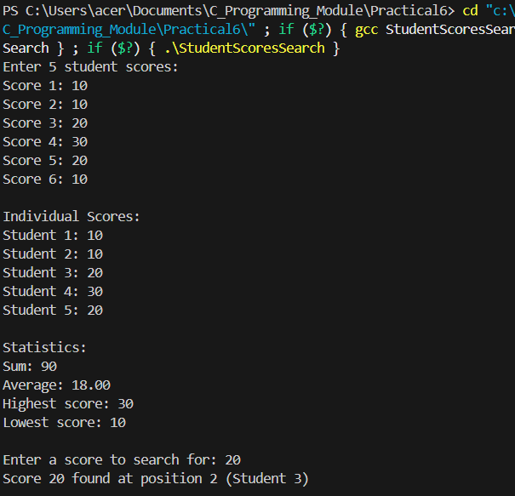

-A user tries to access an array element beyond its bounds?
As mentioned above, if user tries to access an array element beyond its bound for example 5 in case of scores[], the program will fetch garbage values and result in error in calculation.
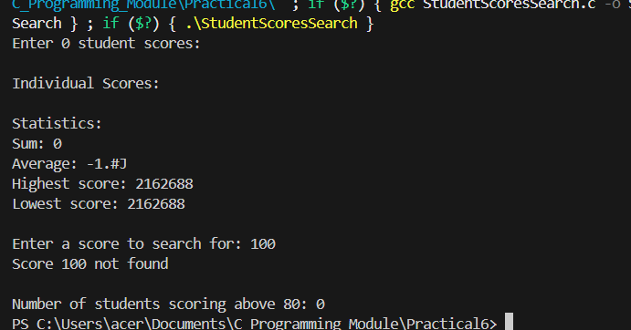
-The size parameter passed to a function is negative or zero?

Results garbage values.
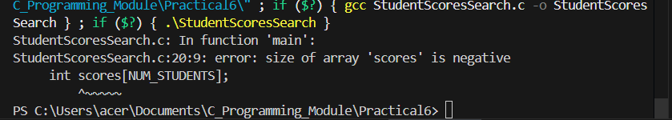
And negative results in error.

Task: Test what happens when you change a loop condition from `i < size` to `i <= size`. What security vulnerability does this create?
- Buffer overflow
- Memory corruption
- Unusual behaviour
- Program crash
Question 2: Input Validation
In your current `readScores` function:
- What happens if the user enters letters instead of numbers?
Scanning terminates immediately and takes garbage values for processing.
-What if they enter negative scores or scores above 100?
No validation, so takes any inputs and processes it.
-How can you validate that scanf successfully read a value?
if(!readScores(scores, NUM_STUDENTS)){
printf("Error: Failed to read scores. Program terminated.\n");
return 1;
}
Question 3: Range Validation
For student scores:
-Why is it important to validate these ranges?
So that the range remains between reasonable range of 0-100 and not create unusual calculations.
Task: Create a function `bool validateScore(int score)` that returns true only if the score is between 0 and 100.
bool validateScore(int score){
return(score>=MIN_SCORE&&score<=MAX_SCORE);
}
Question 4: Defensive Parameter Checking
Before using array parameters in functions:
-What should you check about the size parameter?
Check if the size is greater than zero and less than max number of students, if not print error.
if(size<=0||size>MAX_STUDENTS){
printf("Error: Invalid array size.\n");
return false;
}

-Why are these checks important?
- Prevents using garbage data.
- Stops program crashes
- Prevents security exploits from unusual input.
Question 5: Safe Array Access
To prevent buffer overflow:
-What should you verify before accessing `array[i]`?
Verify that the index i is not negative (i>=0) and strictly less than the array size (i<size).
-How can you ensure loop indices never exceed array bounds?
Use “< “ comparison in loop conditions (i<size) and validate the size parameter before starting any iteration.
-What constant should you define to limit maximum array size?
Define a maximum limit constant (e.g., #define MAX_STUDENTS 100) to prevent stack overflow.

3(b)
Question 6: Sorting Algorithm Security

When implementing sorting algorithms:
-What happens if you access `array[i+1]` when `i` is at the last position?
Accessing array[i+1] at the last position causes out-of-bounds access, reading garbage memory or crashing.

-How can you ensure comparison operations don't exceed array bounds?
Ensure loop conditions stop at size -1 (e.g., i<size-1)
-What should you validate before starting a sort?
Validate array pointer is not NULL and size is within limits (like validateArrayParams) before starting.
Question 7: Swap Operation Safety

When swapping array elements:
-What should you verify about the indices before swapping?
Verify both indices are not negative and strictly less than the array size (0<=index<size).
-Could swapping cause any security issues?
Yes, invalid indices allow random memory writes, potentially corrupting data or enabling exploits.
-How do you ensure both indices are valid?
Validate both indices against the array size using a check similar to validateArrayParams before swapping.

